

**Major Project Report**

**on**

**Project Title: -**

Hospital Patient Management System

**Course: PROGRAMMIG METHODOLOGIES-LABORATORY**

**Course Code: CAP173**

|  |  |
| --- | --- |
| **Submitted by**  Mona Raj  Reg ID: 12417598  Section: D2404 | **Submitted to**  Ms. Anjana Sharma  Assistant Professor, SCA, LPU |

**Lovely Faculty of Technology & Sciences**

**School of Computer Applications**

**Lovely Professional University**

**Punjab**

# ****Title of the Project:****

Hospital Patient Management System

# Problem Statement:

This This project implements a patient management system for hospitals. The system allows users to perform operations such as viewing, adding, searching, editing, and deleting patient records. The program involves the following operations:

* 1. Displaying a menu for user input
  2. Viewing pre-defined patient records.
  3. Adding new patient records.
  4. Searching for a patient by ID.
  5. Editing existing patient records.
  6. Deleting patient records.

# Objectives of the Proposed Project:

1. Create a system to manage patient records effectively.
2. Allow users to perform CRUD (Create, Read, Update, Delete) operations.
3. Ensure accurate record maintenance and retrieval.
4. Provide a simple interface for hospital staff.

# System Requirements:

* 1. **Front-End**: Command-line interface for user interaction.
  2. **Back-End**: Implemented in C language using structures and functions.

## Flowchart/Algorithm:

1. Display menu options (View, Add, Search, Edit, Delete, Quit).
2. Take user input for menu selection.
3. Perform corresponding operations using functions.

* View: Display all patient records.
* Add: Allow the user to enter a new record.
* Search: Search records by patient ID.
* Edit: Modify details of a selected patient.
* Delete: Remove patient information by resetting fields.

1. Exit when the user selects "Quit".

## Input:

1. User choice from the menu.
2. Patient details (ID, name, age, gender, bill).

## Output:

1. Display of patient records.
2. Confirmation of successful CRUD operations.

# Constraints:

1. The program is limited to five patient records at a time.
2. Patient IDs must be unique.
3. The menu requires single-character input (V, A, S, E, D, Q).
4. Default patient records are pre-defined.

# Benefits of the Proposed Project:

1. Simplifies hospital record management.
2. Provides an easy-to-use interface for performing operations.
3. Allows efficient searching and editing of records.
4. Serves as a foundation for building advanced management systems.

# Expected Outcomes:

1. A functional patient management system capable of handling basic operations.
2. Accurate and consistent maintenance of patient data.
3. User-friendly interaction for hospital staff.

# Future Scope:

1. Extend the system to handle more patient records dynamically using file handling or databases.
2. Implement a GUI for better usability.
3. Add features like patient history and billing details.
4. Include user authentication for data security.
5. Integrate reporting tools to generate summaries.

# Coding Screenshots:

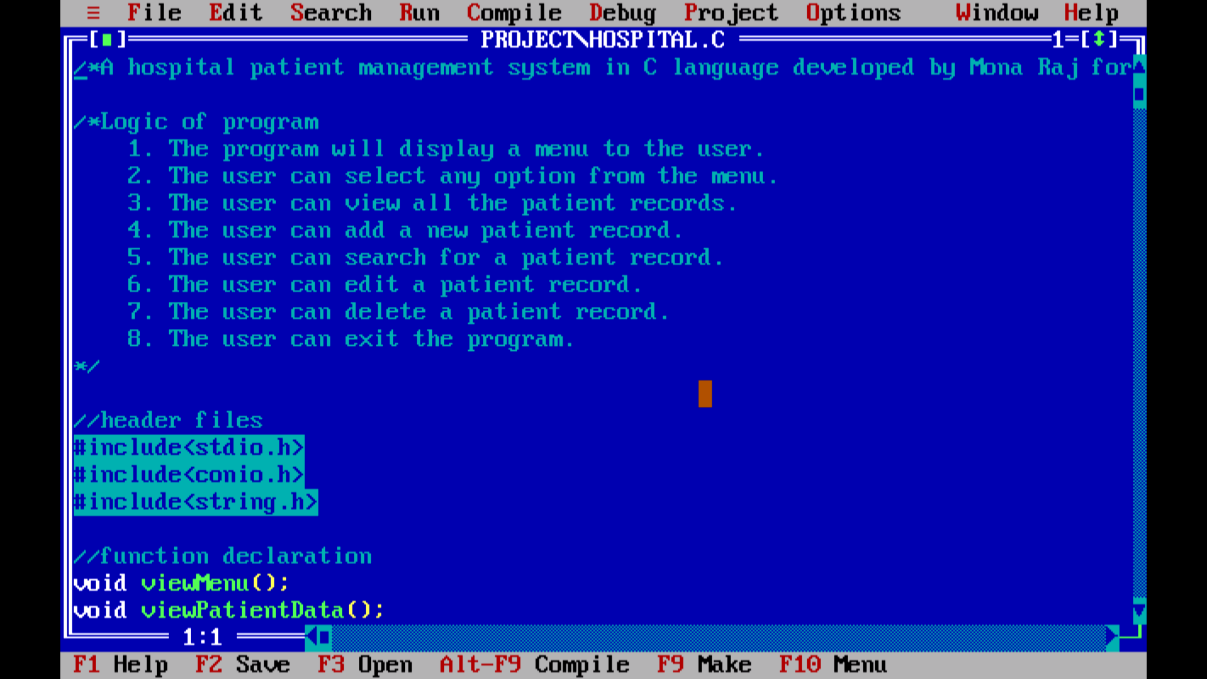

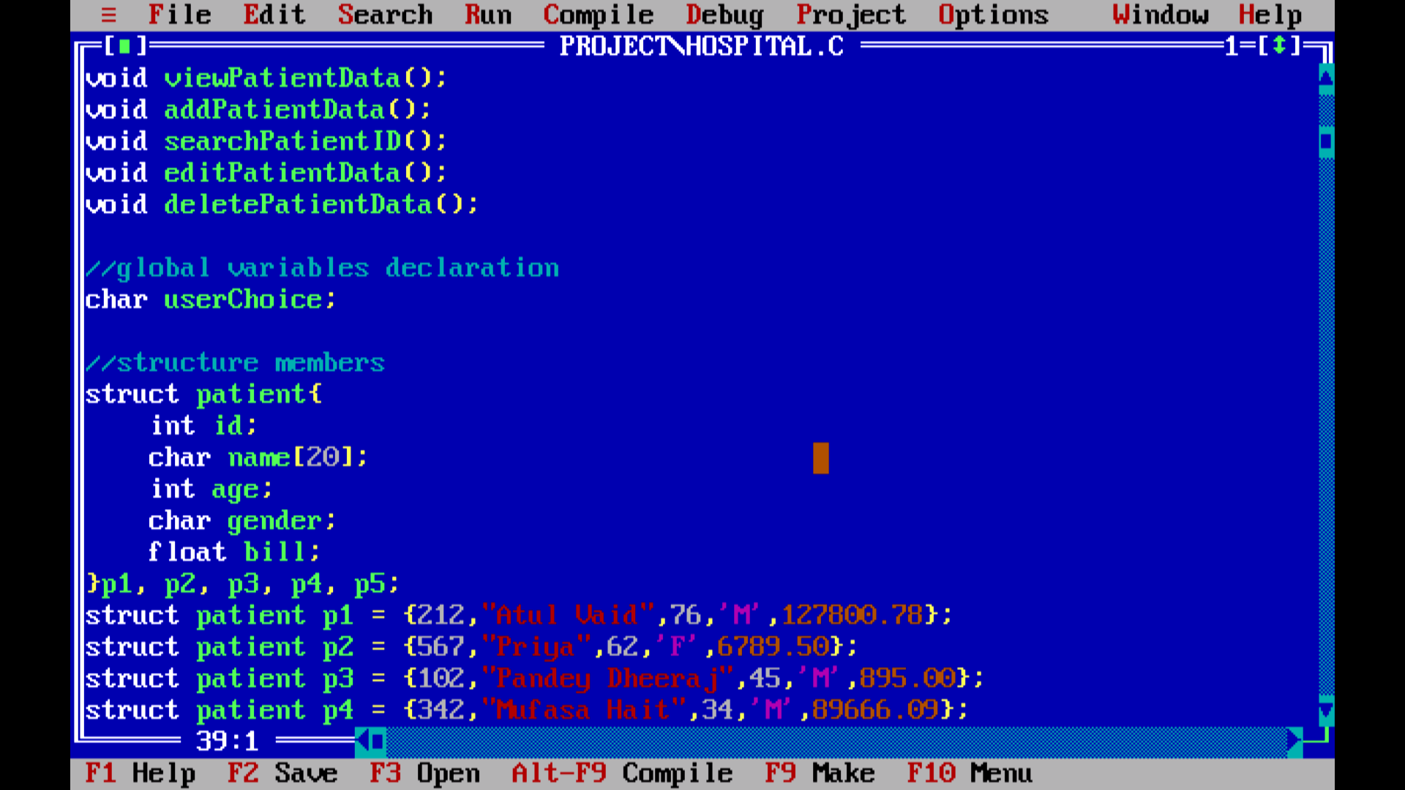

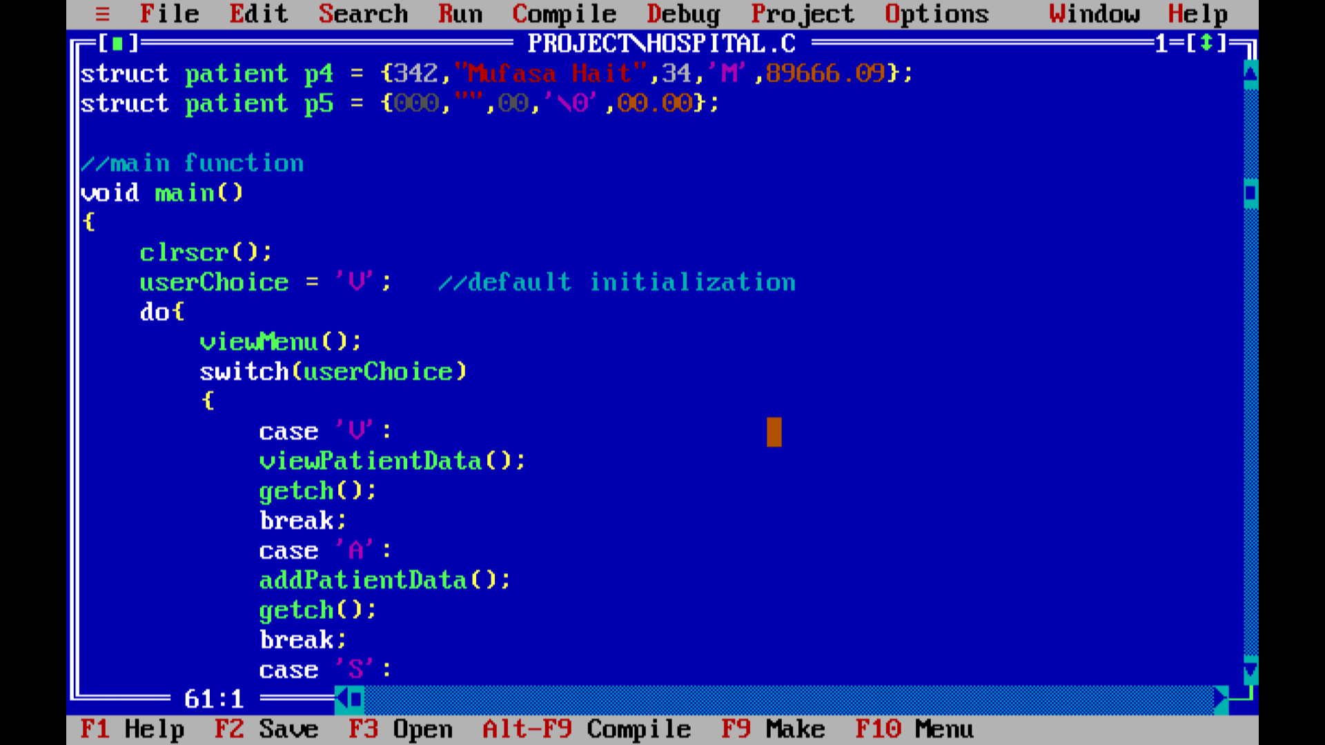

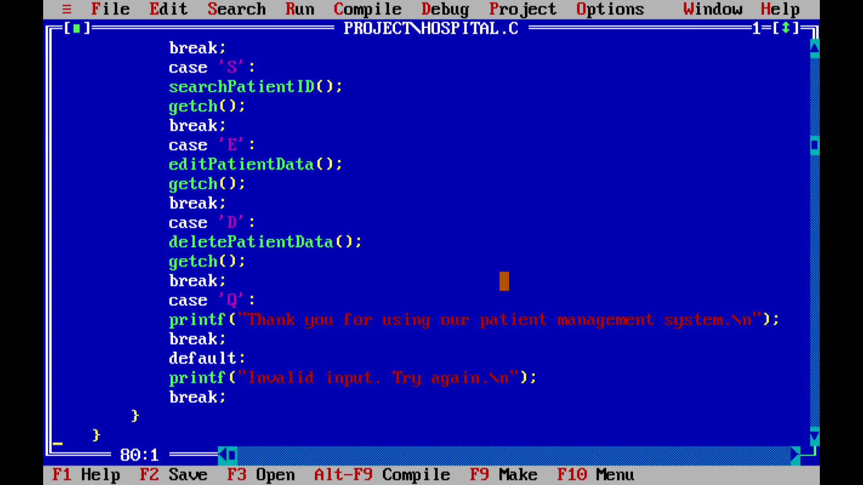

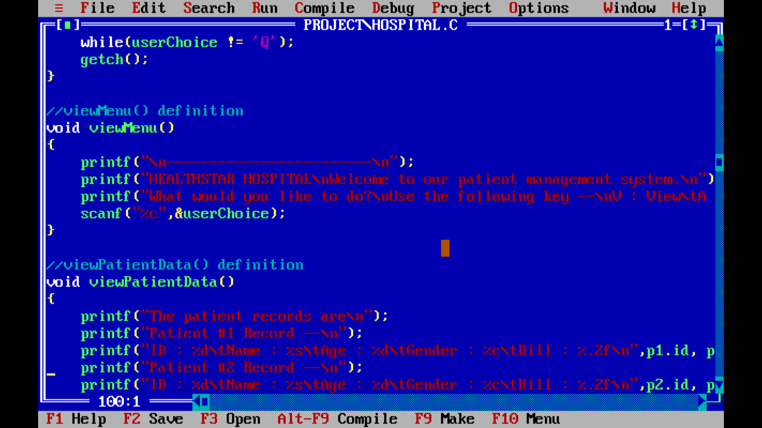

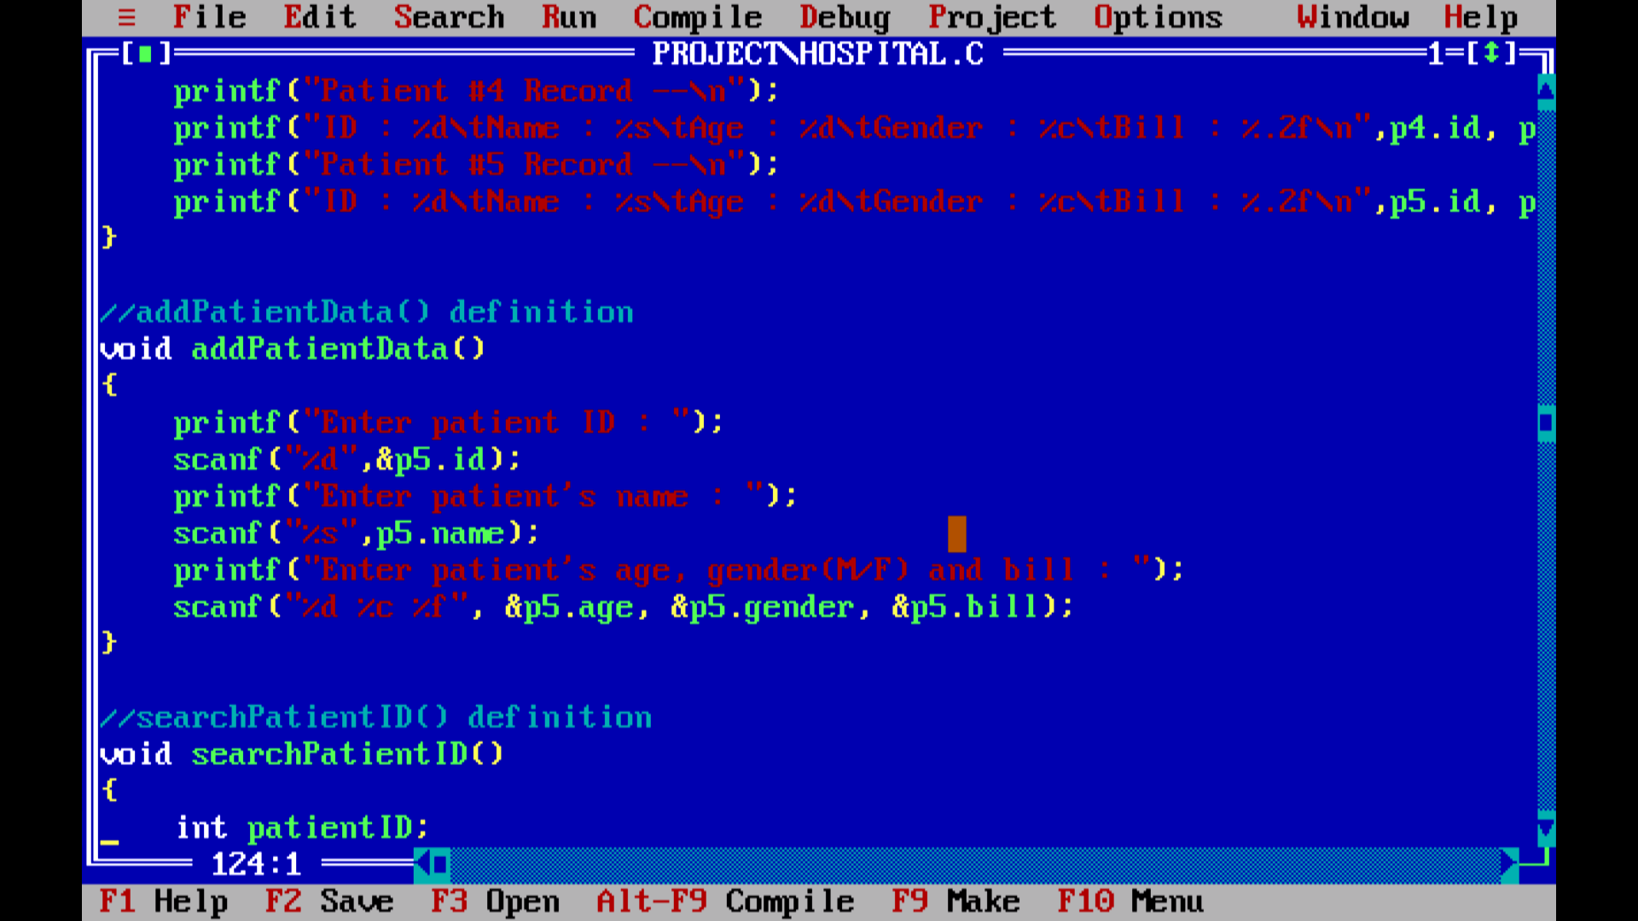

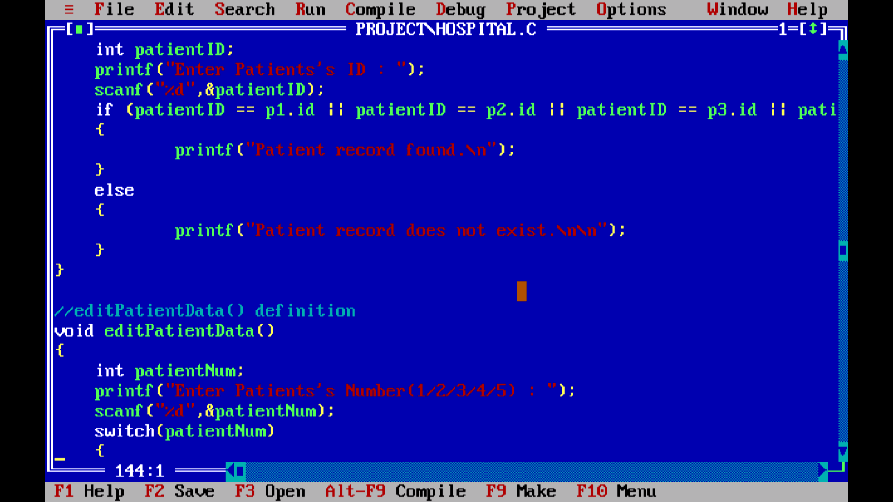

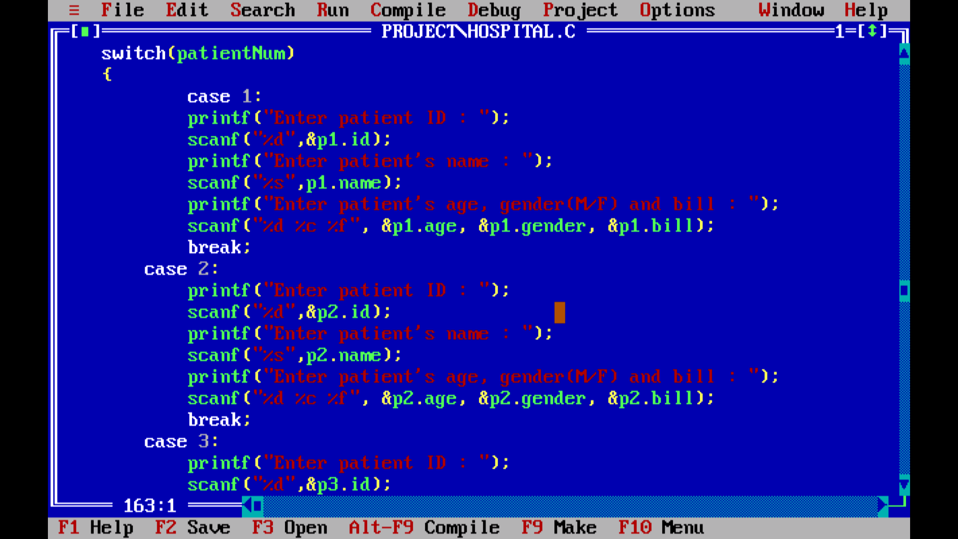

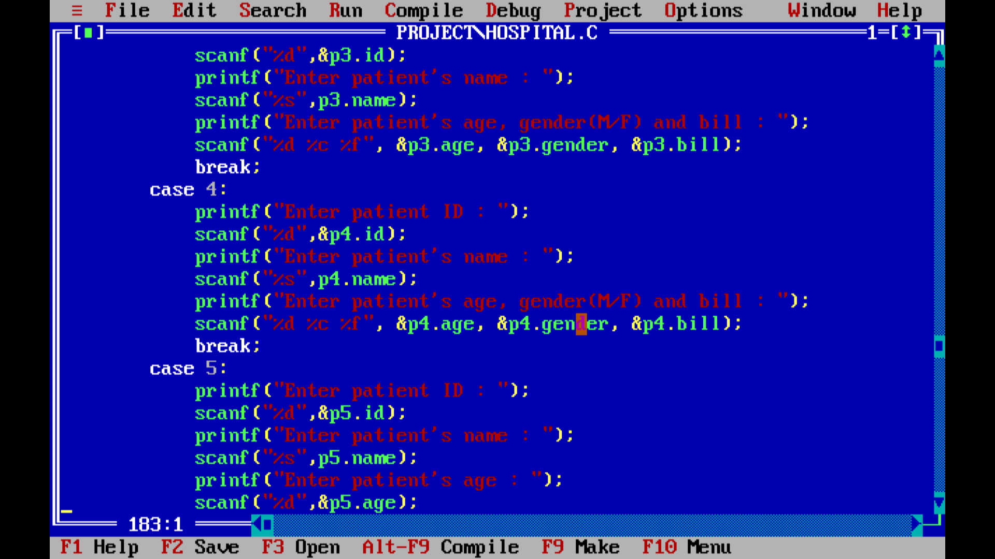

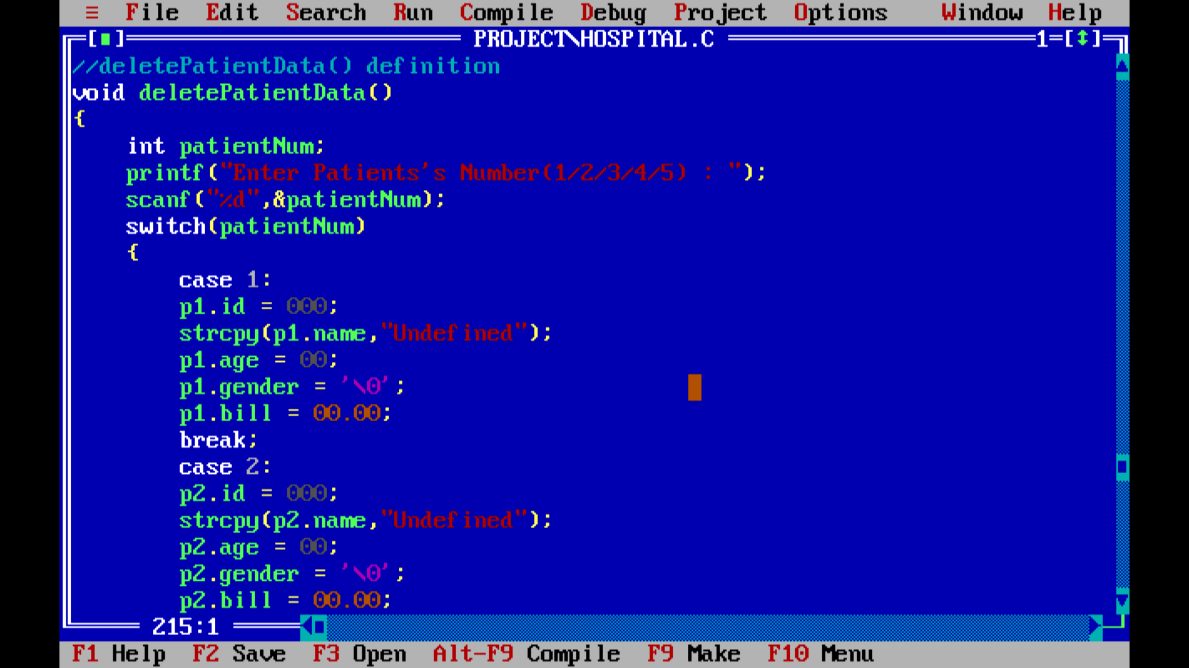

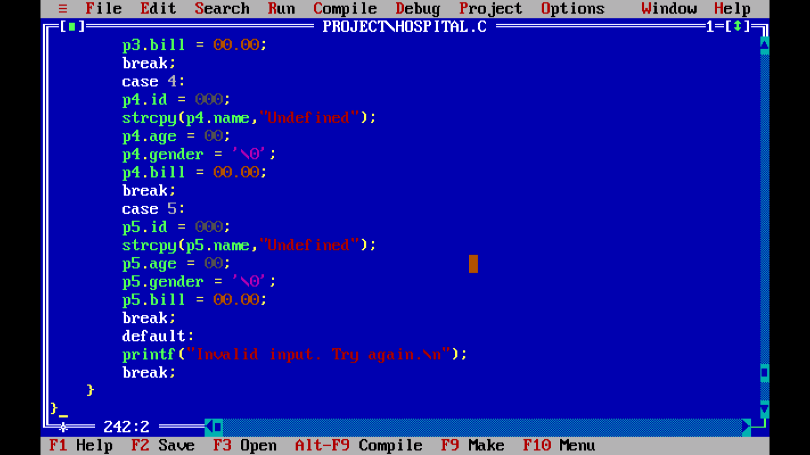

# Results screenshots:

